Title: Array Manager – Add & Delete Items Dynamically

Requirements:
- Create a simple UI with:
  - One text field
  - One Add button
  - One unordered list (ul) to display items
- When user enters text and clicks “Add”:
  - The value should be stored in a JavaScript array
  - The array should update visually in the UI (append new item to the list)
- Each displayed list item must have a small “Delete” button:
  - When user clicks “Delete”:
    - That item must be removed from the array
    - The UI must update and show the new array data
- The goal is to practice:
  - Array methods (push, splice, indexOf, filter, etc.)
  - DOM methods (createElement, appendChild, removeChild)
  - Understanding array + UI sync
- Bonus for students:
  - Show a message if input is empty
  - Avoid adding duplicate items
Output:
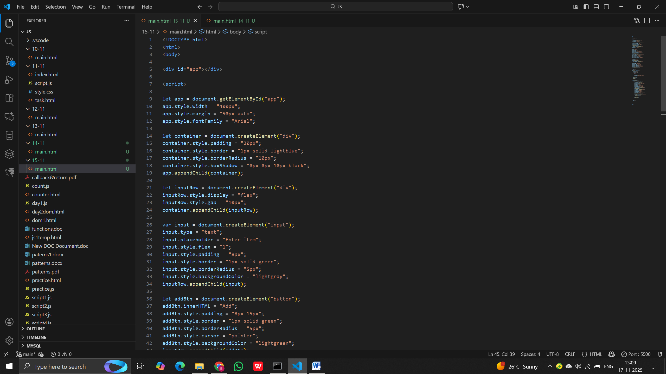

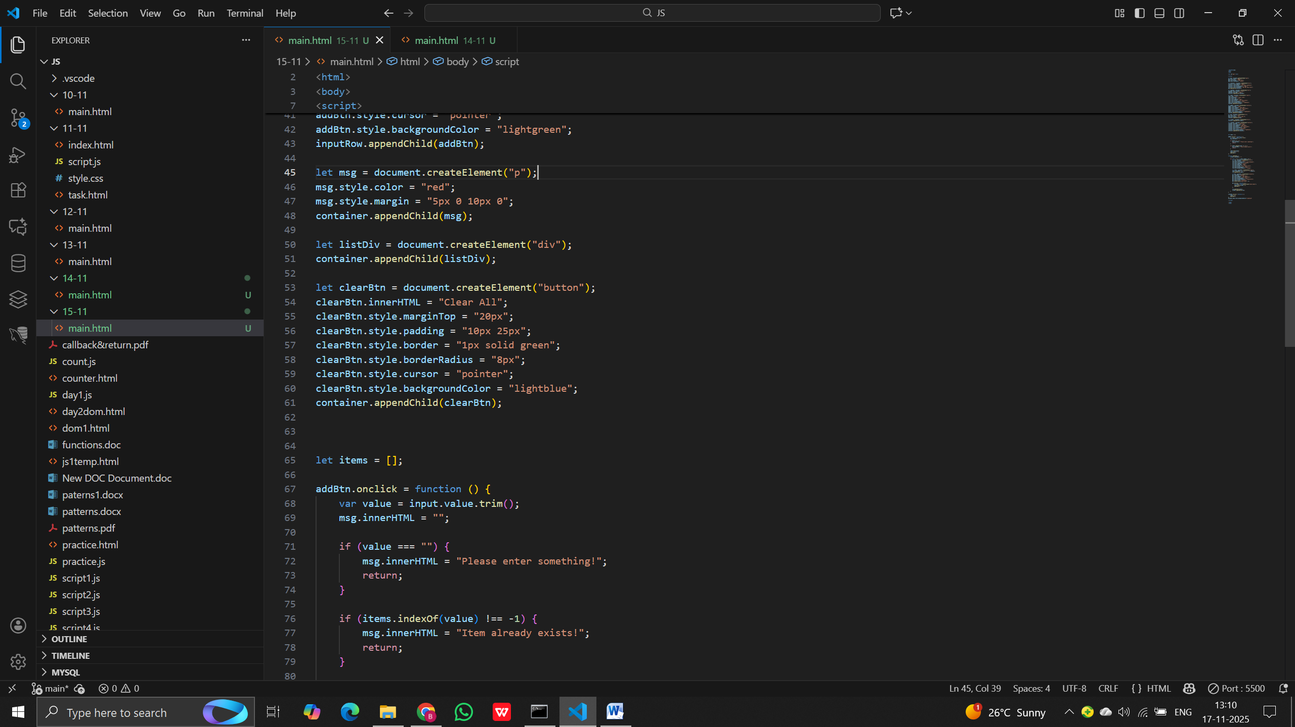

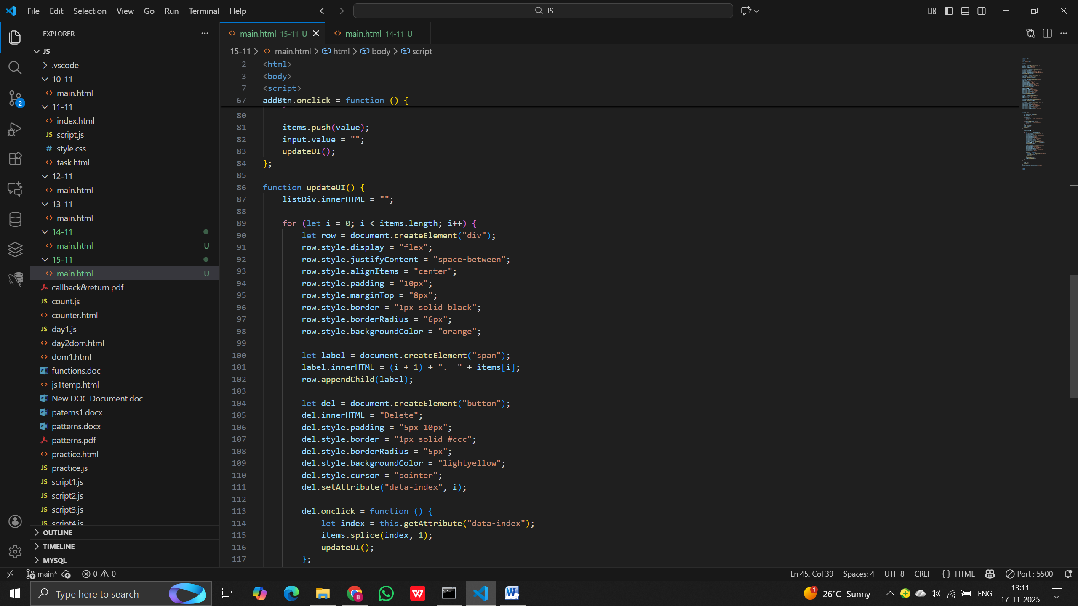
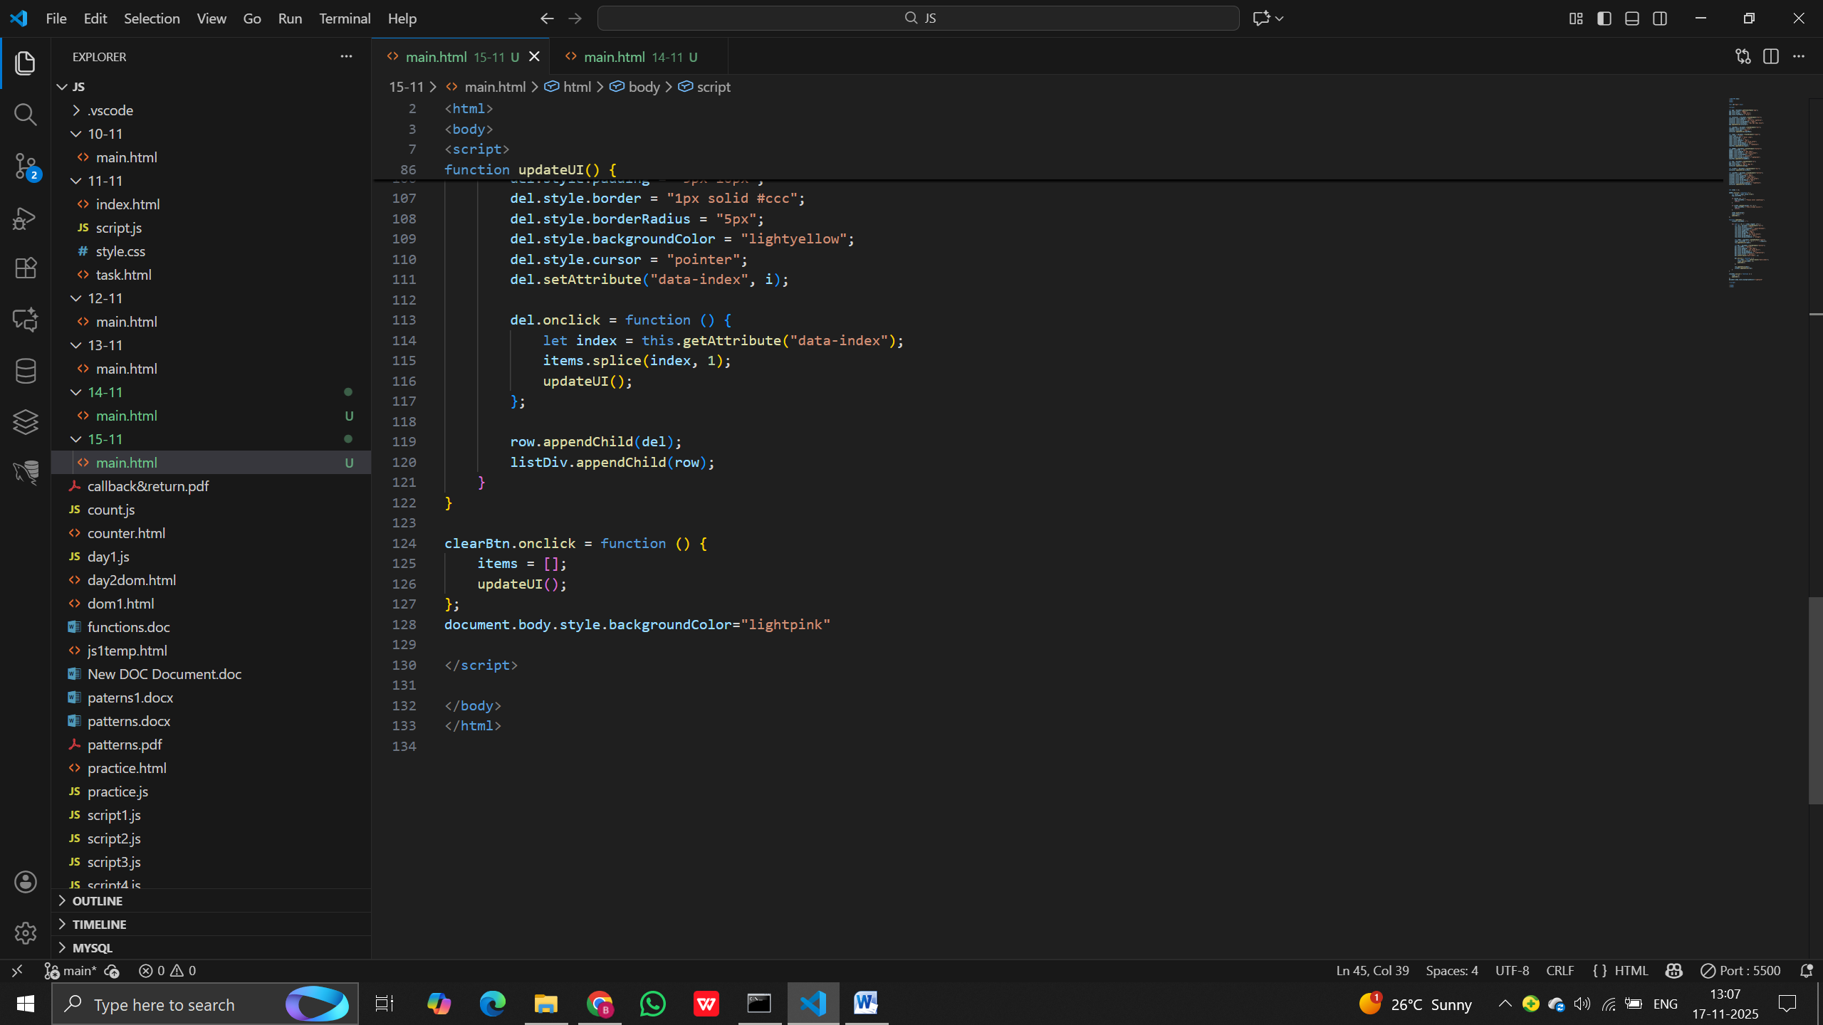

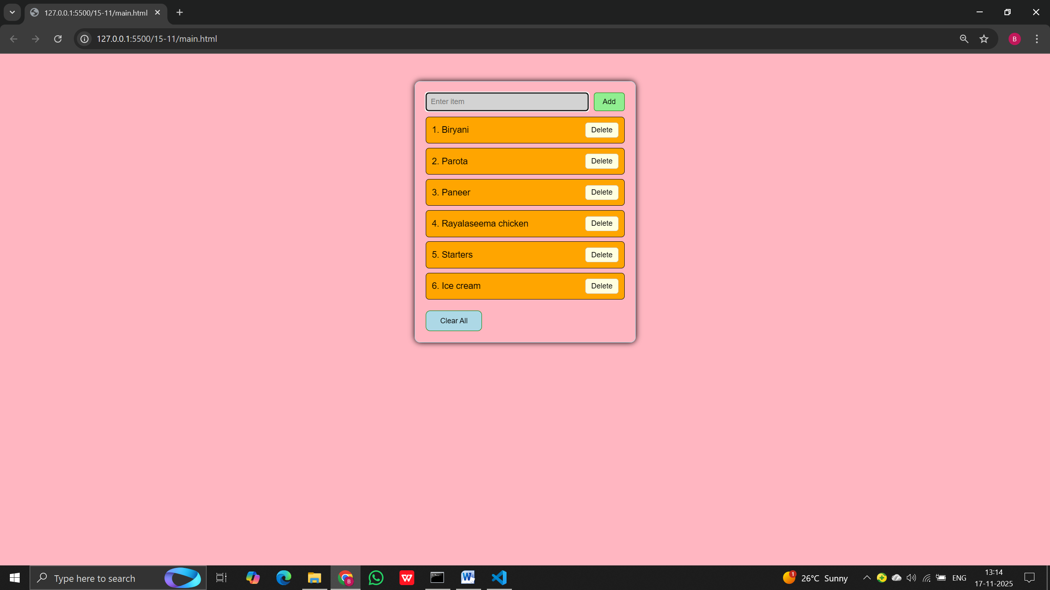

1. Which method adds an item to the end of an array?
a) unshift()
b) push()
c) shift()
d) pop()
Answer: b

2. Which method removes the first element in an array?
a) pop()
b) shift()
c) slice()
d) splice()
Answer: b

3. What does pop() return?
a) First element
b) Last element
c) Entire array
d) Undefined
Answer: b

4. Which method is used to join array elements into a string?
a) join()
b) concat()
c) map()
d) toString()
Answer: a

5. Which method creates a new array without modifying the original?
a) splice()
b) slice()
c) push()
d) pop()
Answer: b

6. What will indexOf() return if the item is not present?
a) 0
b) -1
c) null
d) undefined
Answer: b

7. Which method is used to remove/replace items in an array?
a) splice()
b) slice()
c) map()
d) filter()
Answer: a

8. Which method creates a NEW filtered array?
a) splice()
b) push()
c) filter()
d) shift()
Answer: c

9. What does arr.concat(b) do?
a) Updates arr directly
b) Returns a new merged array
c) Deletes elements
d) Converts to string
Answer: b

10. Which method returns the length of the array?
a) size()
b) length()
c) arr.length
d) count()
Answer: c

Output-Based Questions on Array Methods

1.
let arr = [1, 2, 3];
arr.push(4);
console.log(arr);

Output: [1, 2, 3, 4]

2.
let arr = ["a", "b", "c"];
console.log(arr.pop());

Output: c

3.
let a = [10, 20, 30];
a.shift();
console.log(a);

Output: [20, 30]

4.
console.log(["x","y","z"].indexOf("y"));

Output: 1

5.
let arr = [5,10,15,20];
console.log(arr.slice(1,3));

Output: [10, 15]

6.
let arr = [1,2,3];
arr.splice(1,1);
console.log(arr);

Output: [1,3]

7.
let a = [2,4,6];
let b = a.concat([8,10]);
console.log(a, b);

Output:
[2,4,6] [2,4,6,8,10]

8.
let arr = ["js","html","css"];
console.log(arr.join("-"));

Output: "js-html-css"

9.
let arr = [1,2,3,4];
let res = arr.filter(n => n % 2 === 0);
console.log(res);

Output: [2,4]

10.
let arr = ["a","b","c"];
arr.unshift("z");
console.log(arr);

Output: ["z","a","b","c"]

